NAME: SAMRENDRA NARAYAN SINGH

STUDENT ID: 47961171

DATA AND VISUALIZATION FOR BUSINESS

ASSIGNMENT 2
VISUALIZATION TASK

SUBMITTED TO GENG SUN

PART A
DATA VISUALIZATION
I have used R language in this project to complete the visualization tasks. I have decided to keep one visualization per page.
VISUALIZATION 1

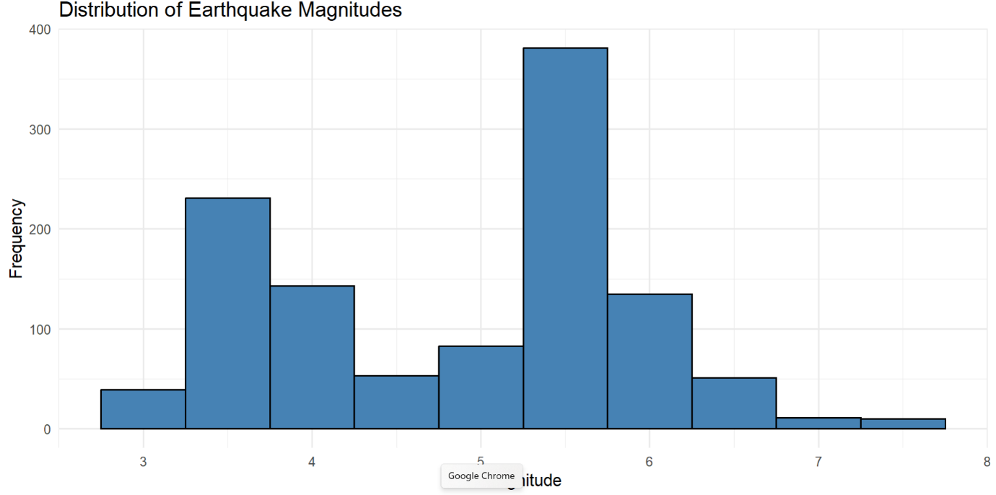
The above chart describes the distribution of earthquake magnitudes. The x-axis represents the magnitude of the earthquakes. The y-axis represents the frequency of the earthquake magnitudes. The lowest magnitude is 3 and the highest magnitude is roughly 7,5 (between 7 and 8).
Recommendations
- The frequency of earthquakes with lower magnitudes is much higher compared to earthquakes of higher magnitudes. So, we need to focus on strategies for dealing with earthquakes of lower magnitudes.

- The frequency of earthquakes with higher magnitudes is relatively less, even then they pose a significant risk to life and property. Hence contingency plans must be developed for the possibility of earthquakes with high magnitudes.

- Utilize technology to save lives by investing in and implementing early warning systems. This will give the people time to leave for a safer location. Additionally, it is beneficial to regularly conduct assessments regarding seismic hazards, which can be useful in identifying locations at higher risk.

VISUALIZATION 2

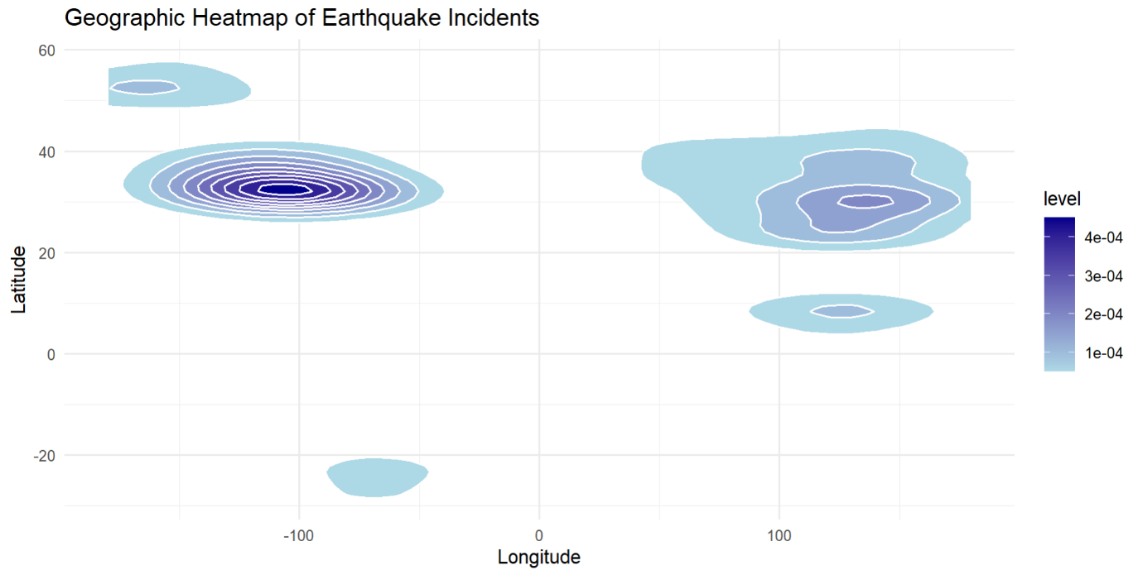

The heatmap describes the distribution of earthquakes based on location and geographical features. The x-axis represents the longitude and the y-axis represents the latitude. The darker colors represent regions with higher concentrations of earthquakes, while lighter colors indicate regions with lesser concentrations of seismic activities.
Recommendations
- Focus preparedness on regions with records of higher seismic activity. This includes enforcing rigorous building codes so that various structures and buildings can withstand earthquakes. Also running public awareness campaigns consistently can help in minimizing the impact of earthquakes on people.

- Advancement in emergency response protocols, early warning systems, and building codes is possible. Hence promoting research about earthquake prevention and mitigation techniques is imperative.

- Work with countries having similar seismic activities. Collaborating with them will be beneficial from various angles like earthquake prevention, development of science, and international, etc. Invest in infrastructure resilience and technology to mitigate the impact of earthquakes and similar seismic activities. Prioritize earthquake-resistant infrastructure.

VISUALIZATION 3

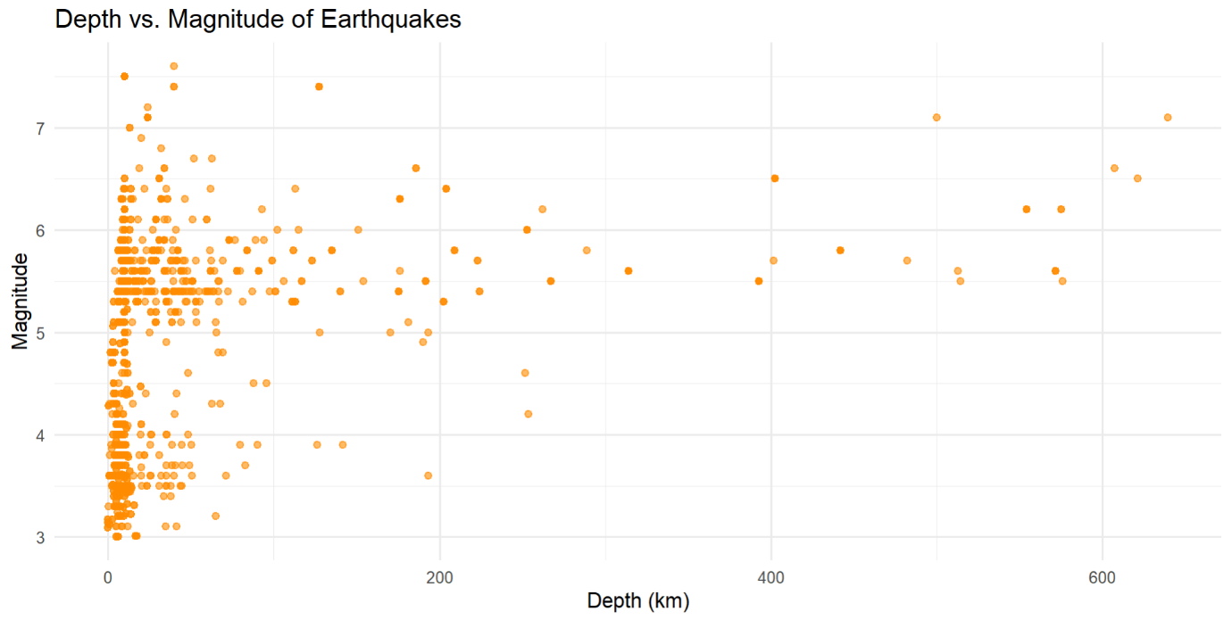
This visualization depicts the Depth of earthquakes (in km) on the x-axis and the Magnitude on the y-axis. We see that most of these earthquakes occur at shallow depths (between 0 to 200 km). An inversely proportional relationship between the depth and magnitude of earthquakes can be observed. The frequency and magnitude of earthquakes seem to be decreasing as the depth increases. Low-magnitude earthquakes occur more frequently compared to earthquakes with high magnitude.
Recommendations
- The frequencies of shallow earthquakes (earthquakes of low depth) are higher compared to deep earthquakes (earthquakes of greater depth). So, the focus for strategies should be on dealing with shallow earthquakes.

- The frequency of earthquakes with higher magnitudes is relatively less, even then they pose a significant risk to life and property. Hence contingency plans must be developed for the possibility of earthquakes with high magnitudes.

- Regularly conduct assessments about seismic hazards, which can be useful in identifying locations at higher risk. This can make it possible to save lives simply by implementing an early warning system (investing in technology).

VISUALIZATION 4

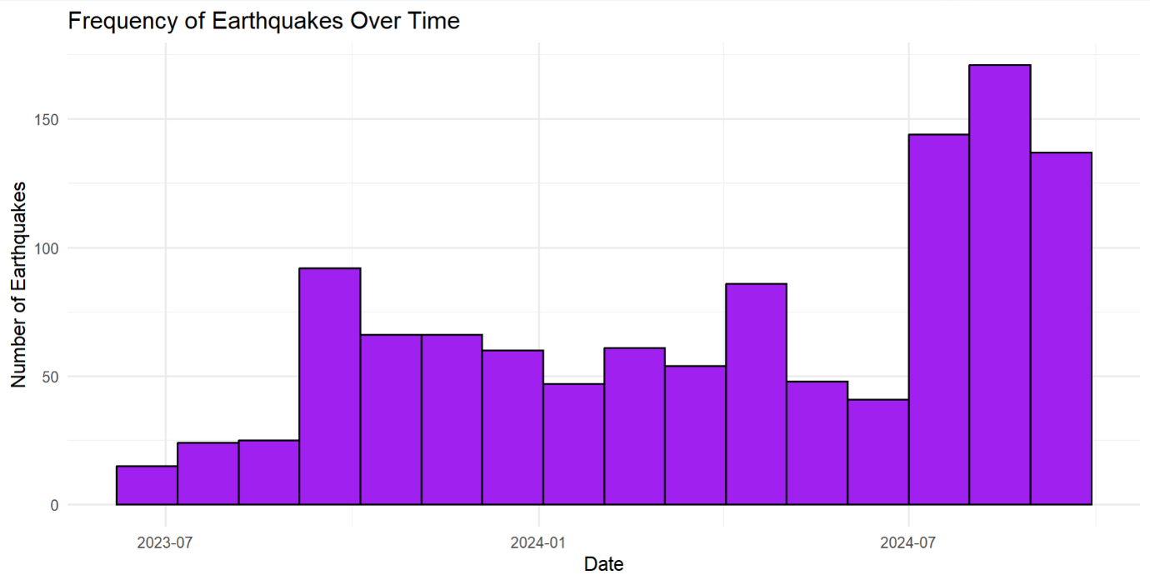
The chart tells the number of earthquakes roughly between July 2023 to September 2024. The number of earthquakes is visible on the y-axis and the Date is represented on the x-axis. We can see a high frequency of earthquakes, followed by a low frequency, indicating fluctuating frequencies of earthquakes.
Recommendations
- Enhancing seismic monitoring and surveillance systems is important, given the visible increase in the frequency of earthquakes. To improve detection and location accuracy, maintaining and expanding the network of seismometers is necessary.

- A preparedness and robust plan is the need of the hour because of the potential rise in earthquakes and seismic activity. This includes ensuring the availability of adequate resources along with regular drills and training of emergency responders.

- Large earthquakes near coastlines can trigger potential tsunamis. Earthquakes often generate aftershock waves. Investing in technology and developing warning systems can help prevent further damage.

VISUALIZATION 5

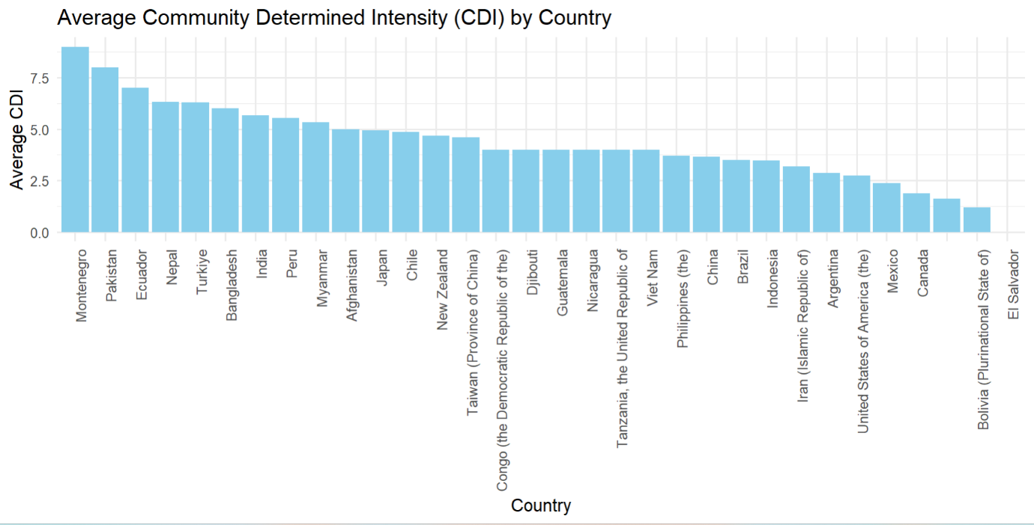

This graph tells the story of the Average Community Determined Intensity (CDI) by Country. The X-axis represents the Country and the Y-axis represents the Average CDI. The top 3 countries by Average CDI are Montenegro, Pakistan, and Ecuador. The bottom 3 countries in terms of Average CDI include Canada, Bolivia, and El Salvador.
Recommendations
- Earthquake preparedness should be a top priority for countries with High average CDI (Montenegro, Pakistan, and Ecuador, etc). Investing in technology (early warning systems, etc), conducting regular drills, and developing emergency response plans are part of this initiative.

- Based on the seismic and geographical data, making a hazard profile and creating tailored strategies will be beneficial for each country. This will also enable them to cooperate with countries having a similar profile, making them one step closer to fostering peace and good international relations.

- Considering social and economic factors like income disparity and inadequate infrastructure can help in the formulation of better emergency response plans.

PART B
DESCRIPTION OF THE DATA ANALYTICS PROCESS FOR DATA GOVERNANCE
The data governance process is a structured approach to managing data through its lifecycle. There are four stages in the data analytics process in the context of data governance. Let us explore and understand them.

DATA COLLECTION
Data governance plays a vital role in this stage by defining data standards, ensuring data quality, and establishing data security protocols. In this initial phase of data analytics, data is collected from various sources such as systems and repositories.
R/Tableau Features:
- R: Includes packages like readr and dplyr that facilitate data collection and cleaning.
- Tableau: Able to connect to diverse data sources (such as databases and cloud platforms).
Data Governance Considerations:
- Data Standards: It is important to define clear data standards, including naming conventions, data types, and formats.
- Data Quality: Implement data quality checks to ensure accuracy, completeness, and consistency.
- Data Security: Establish robust security measures for protecting sensitive data (encryption, access controls, etc).
- Data Privacy: Adhere to privacy regulations like GDPR and CCPA to safeguard personal information.

DATA STORAGE
Data governance ensures data integrity, accessibility, and retention. This involves securely storing collected data for future analysis
R/Tableau Features:
- R: For the purpose of storing data, R can connect to various databases, including SQL and NoSQL.
- Tableau: Connects directly to data sources or stores data in the form of extracts.

Data Governance Considerations:
- Data Retention Policy: To determine how long data should be stored, clear data retention policies should be formulated.
- Data Backup and Recovery: To protect against data loss, implement robust backup and recovery procedures.
- Data Access Controls: Restrict the access of data to authorized personnel only.
- Data Encryption: Enhance security by encrypting the data of sensitive nature.

DATA PROCESSING
Data Processing: This stage involves transforming raw data into a usable format for analysis. Data governance ensures data consistency, accuracy, and compliance with data standards.
R/Tableau Features:
- R: Packages like dplyr and tidyr facilitate data cleaning, transformation, and manipulation.
- Tableau: Data preparation tools like Tableau Prep are offered by Tableau to standardize and transform data.
Data Governance Considerations:
- Data Transformation Rules: Transform and standardize the data by establishing clear rules.
- Data Validation: Identify and correct errors by implementing checks for validation of data.
- Data Lineage: To improve accountability and traceability, tracks the origin and transformation of data.

DATA ANALYSIS AND VISUALIZATION
Data governance ensures that the analysis and visualizations are accurate, unbiased, and aligned with business objectives.
Data visualization presents processed data and insights derived from it in a visually appealing and refined manner

R/Tableau Features:
- R: Shiny and ggplot2 are packages that create insightful visualizations and interactive dashboards.
- Tableau: Provides a user-friendly interface for building interactive visualizations and dashboards.
Data Governance Considerations:
- Data Security and Privacy: Ensure compliance with privacy regulations, by protecting sensitive data.
- Data Accuracy: Validate the accuracy of visualizations and analysis.
- Data Bias: Take steps to mitigate biases in data and its analysis, by becoming aware of them.
- Data Ethics: Ensure that data analysis and visualization are used ethically and responsibly.
Large organizations often establish dedicated data governance teams to oversee data management practices. Effective data governance can significantly enhance data visualization by:
- Improving Data Quality
- Enhancing Data Security
- Facilitating Data Access
- Promoting Data Literacy
By implementing robust data governance practices, organizations can unlock the full potential of data analytics and make informed decisions.

ETHICS IN DATA VISUALIZATION

Accuracy and Truthfulness:
- Principle: Ensuring the accurate representation of data free from manipulation and distortion.
- Relevance: We are living in the age of information and simply communicating the data has been made possible by data visualization. Misrepresentation of data can lead to misleading conclusions and harmful decisions.

Clarity and Transparency:
- Principle: Avoid misleading elements to make the visualizations clear and comprehensible.
- Relevance: Hiding data can undermine trust and interrupt effective communication. A visualization that is well-designed helps the viewer easily understand the information.

Fairness and Non-discrimination:
- Principle: Avoid creating visualizations that could perpetuate biases or discrimination.
- Relevance: It is important to be mindful of how choices might affect various groups. Data visualization is a powerful tool for storytelling and can be used to reinforce or challenge existing narratives.

Respect and Privacy:
- Principle: It is important to anonymize personal information within the data so that privacy can be preserved and protected.
- Relevance: Visualizing sensitive data without proper safeguards can lead to ethical violations in the age of information.

Contextualization:
- Principle: Provide sufficient context to help the viewer interpret the data correctly.
- Relevance: Providing relevant background information to the viewer is important as it helps them make informed judgments. Also without context, data visualizations can be misinterpreted. Diversity and Inclusivity:
- Principle: Design visualizations that are accessible to people with diverse backgrounds and abilities.
- Relevance: Data visualization should be inclusive and avoid barriers that might exclude certain groups.

DISCUSSING THE JUSTIFICATION AND PREDICTIONS RELATED TO THE VISUALIZATIONS

Visualization 1
Justification
The chart provides a clear and concise view of the distribution of earthquakes and their magnitudes. Which makes it easier to identify trends compared to a table of numbers. The distribution suggests that earthquakes of small magnitudes are more frequent than those of high magnitudes. This can help make building codes and standards, so structures can endure seismic activity. Insurance companies can use it to assess risk and make insurance plans accordingly.
Prediction
Though it might not be feasible to predict the exact location of earthquakes based on this chart, we can understand that the probability of occurrence of smaller earthquakes is higher compared to the occurrence of bigger earthquakes.

Visualization 2
Justification
The heatmap provides a clear and concise view of the spatial distribution of earthquakes. Which makes it easier to identify trends compared to a table of numbers. Allows for quick identification of regions with high seismic activity. This can help in urban planning and construction, so structures can endure seismic activity. Additionally, insurance companies can use it to assess risk and make insurance policies accordingly.

Prediction
It is not simple to predict the exact time and location of earthquakes. However, we can infer from the chart that regions with high earthquake density are more likely to be affected by seismic activities and earthquakes in the future. The clusters likely correspond to active zones of tectonic plate movement.

Visualization 3
Justification
Besides clearly depicting the visual relationship between the magnitude and depth of earthquakes, the scatter plot allows for the identification of clusters. Also helps in understanding the correlation between magnitude and depth of earthquakes.
Prediction
Based on the plot, we can infer that deeper earthquakes tend to have higher magnitudes, indicating a correlation between depth and magnitude. The clustering of data points at certain depths might indicate specific tectonic zones or fault lines with a higher frequency of earthquakes.

Visualization 4
Justification
Besides clearly depicting the earthquake frequencies over time, the bar chart allows us to quickly identify periods with high and low earthquake activity. Also helps in understanding the correlation between magnitude and depth of earthquakes. Identifying periods with high seismic activity can help in emergency planning and responding to disasters. Understanding the temporal patterns can also provide unique insights into the tectonic plates and phenomena related to them.
Prediction
Based on the chart, we can infer that there might be fluctuations in seismic activities in the future (periods of increased and decreased seismic activities). These variations in the earthquake frequency are probably related to tectonic plates or seasonal factors.

Visualization 5
Justification
Besides clearly depicting the earthquake frequencies over time, the bar chart allows us to quickly identify countries with high and low perceived earthquake intensity. Identifying countries with high CDI values can help in emergency planning and responding to disasters. Understanding the distribution of perceived earthquake intensities can help gain insights into the human perception of seismic events.

Prediction
Based on this bar chart, we can infer that countries with higher CDI values are likely to experience more intense earthquakes. CDI reflects the perceived intensity of earthquakes by the local population, which is possibly influenced by social and cultural factors too.

REFERENCES
IBM Data Governance: A Comprehensive Guide
SAS Data Governance: A Primer
O'Reilly Media Data Governance: How to Design a Data Governance Program

